1. Project Team Information
Project Title | AI Fit Track API
Team Leader | Gwyneth Krizane Wingell
Team Leader ID | 24bsccs45@cttewc.edu.in
Team Members | Abitha P (24bsccs09@cttewc.edu.in)  Kamali S (24bsccs07@cttewc.edu.in)  Afrin Asima R (24bsccs10@cttewc.edu.in)
Project Type | Backend Development With Node.js
2. Introduction
AI Fit Track API is a backend REST API developed to manage workout information securely and provide personalized fitness assistance. The project is built using Node.js, Express.js, MongoDB, Mongoose, JWT authentication, and Google Gemini AI.
The backend allows registered users to authenticate securely, maintain workout records, perform CRUD operations, search workout history, and request AI-generated workout recommendations and fitness insights.
3. Project Overview
The main purpose of AI Fit Track is to provide a centralized backend system for fitness tracking. Instead of maintaining workout information manually, users can store their workout history through RESTful APIs and retrieve it whenever required.
A major feature of the system is Google Gemini integration. The AI service accepts information such as age, fitness goal, and experience level and generates a concise personalized recommendation. It can also analyze workout statistics such as total workouts, average duration, and calories burned to produce fitness insights.
4. Objectives of the Project
To develop a secure backend REST API for fitness and workout management.
To implement user registration and login using JWT authentication.
To protect user data with authentication middleware and password hashing.
To perform Create, Read, Update, and Delete operations on workout records.
To provide search functionality for workout history.
To integrate Google Gemini AI for personalized workout recommendations.
To generate AI-assisted fitness insights from workout statistics.
To practice modular backend development using MVC architecture.
To test and validate APIs using Thunder Client.
5. Main Features
- User Registration
- Secure User Login
- JWT Token Authentication
- Protected API Routes
- User Profile Access
- Create Workout
- View Workout History
- Get Workout by ID
- Update Workout
- Delete Workout
- Search Workouts
- AI Workout Recommendation
- AI Fitness Insights
- Centralized Error Handling
- Standard JSON API Responses
6. Project Structure
src/
├── config/
├── controllers/
│ ├── aiController.js
│ ├── authController.js
│ └── workoutController.js
├── middleware/
│ ├── auth.js
│ └── errorHandler.js
├── models/
├── routes/
│ ├── aiRoutes.js
│ ├── authRoutes.js
│ ├── index.js
│ └── workoutRoutes.js
├── services/
│ └── geminiService.js
├── app.js
└── server.js
7. API Development
The application is divided into authentication, workout, and AI route groups. The route index mounts these groups under /auth, /workouts, and /ai.
Module | Route Group | Purpose
Authentication | /api/auth/... | Registration, login, profile and authentication operations
Workouts | /api/workouts/... | Workout CRUD and search operations
AI | /api/ai/workout-recommendation | Personalized workout recommendation
AI | /api/ai/fitness-insights | Fitness progress analysis and insight generation
8. Authentication and Middleware
Authentication is implemented using JSON Web Tokens. A registered user logs in with valid credentials, and the backend generates a JWT. Protected requests include the token in the Authorization header.
User registration creates a new account.
Passwords are hashed using bcrypt.js.
Login verifies credentials and generates a JWT.
Authentication middleware verifies the token before protected operations.
Unauthorized requests are rejected with an appropriate JSON error response.
Centralized error middleware handles application errors consistently.
9. Database Development
MongoDB is used as the primary database and Mongoose is used for schema definitions and database access. The project stores user and workout information in separate collections.
Entity | Important Fields | Purpose
User | _id, name, email, password, timestamps | Stores account and authentication information.
Workout | _id, user, workoutName, category, duration, calories Burned, workoutDate | Stores workout history linked to a user.
10. Google Gemini AI Integration
The AI module is implemented as a separate service so that AI communication is not mixed with route and controller logic. The Gemini service receives structured user information, creates a prompt, sends it to Google Gemini, and returns the generated text to the controller.
10.1 Workout Recommendation
Input: Age
Input: Fitness Goal
Input: Experience Level
Output: Personalized workout recommendation and practical execution guidance
10.2 Fitness Insights
Input: Total Workouts Logged
Input: Average Workout Duration
Input: Total Calories Burned
Output: Personalized fitness progress insight and actionable guidance
11. Environment Configuration
Sensitive configuration values are stored in a .env file and are not hard-coded into the application source.
PORT=5000
MONGO_URI=mongodb://localhost:27017/fittrack
JWT_SECRET=your_secret_key
GEMINI_API_KEY=your_gemini_api_key
GEMINI_MODEL=your_supported_gemini_model
The real Gemini API key must never be included in documentation, screenshots, source control, or shared files.
12. Project Setup
Install Node.js and MongoDB.
Open the AI Fit Track project in Visual Studio Code.
Open the terminal in the project directory.
Install the project dependencies using npm install.
Create a .env file and configure the required environment variables.
Start MongoDB.
Start the backend server using npm start.
Use Thunder Client to test the API endpoints.
npm install
npm start
13. API Testing With Thunder Client
Thunder Client is used inside Visual Studio Code to send HTTP requests and inspect JSON responses. Testing is performed in stages so that authentication and protected routes can be verified before AI endpoints.
Test user registration.
Test user login and obtain the JWT token.
Configure authentication for protected requests.
Test workout creation and retrieval.
Test workout update and deletion.
Test workout search.
Test the AI workout recommendation endpoint.
Test the AI fitness insights endpoint.

Authentication API Testing
Register User
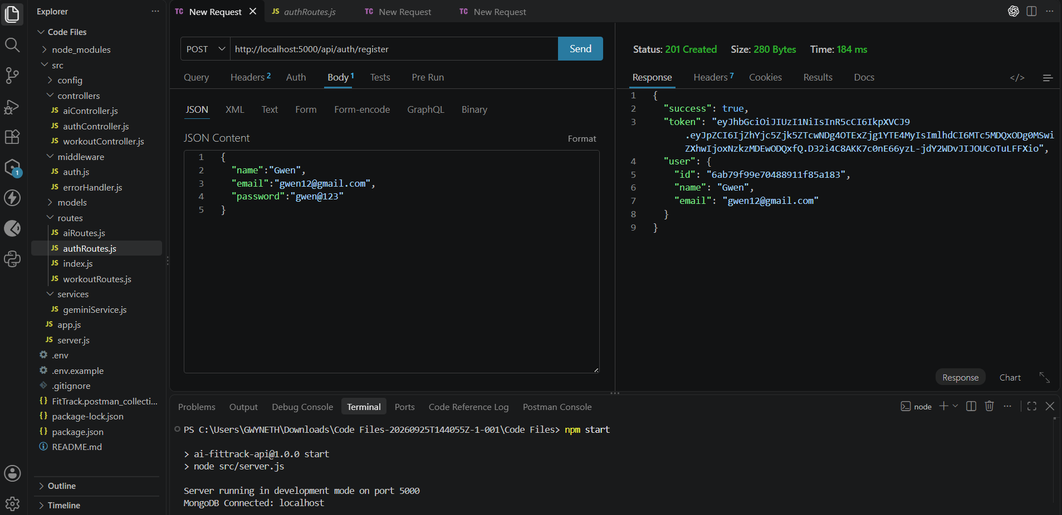
Login User
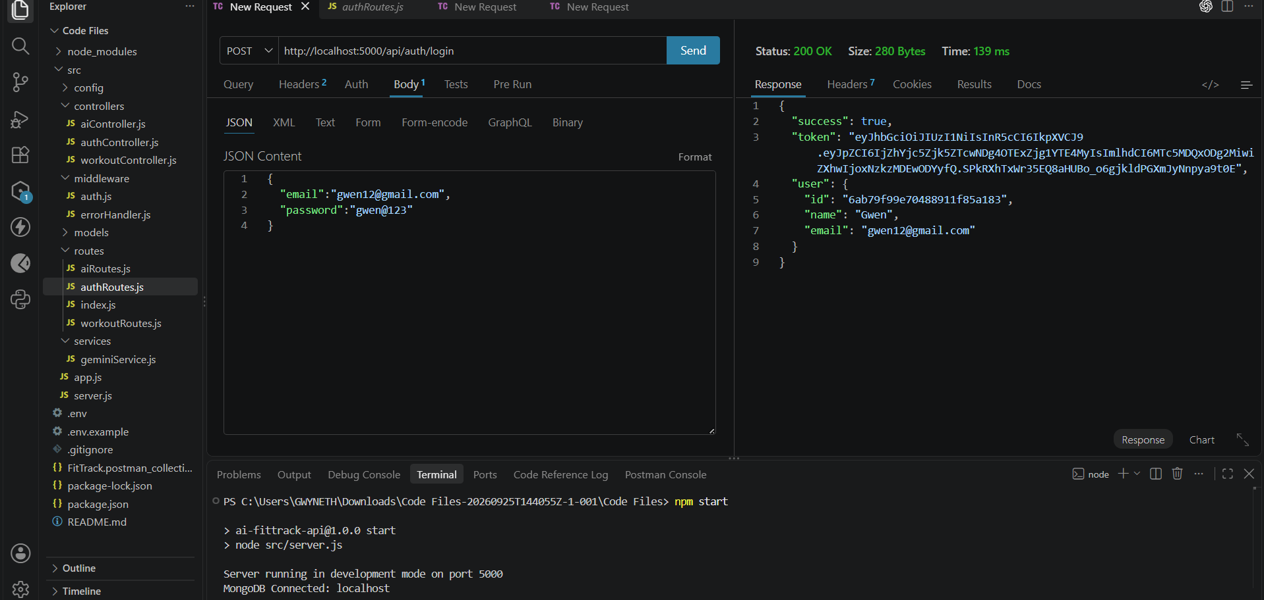
Get Profile
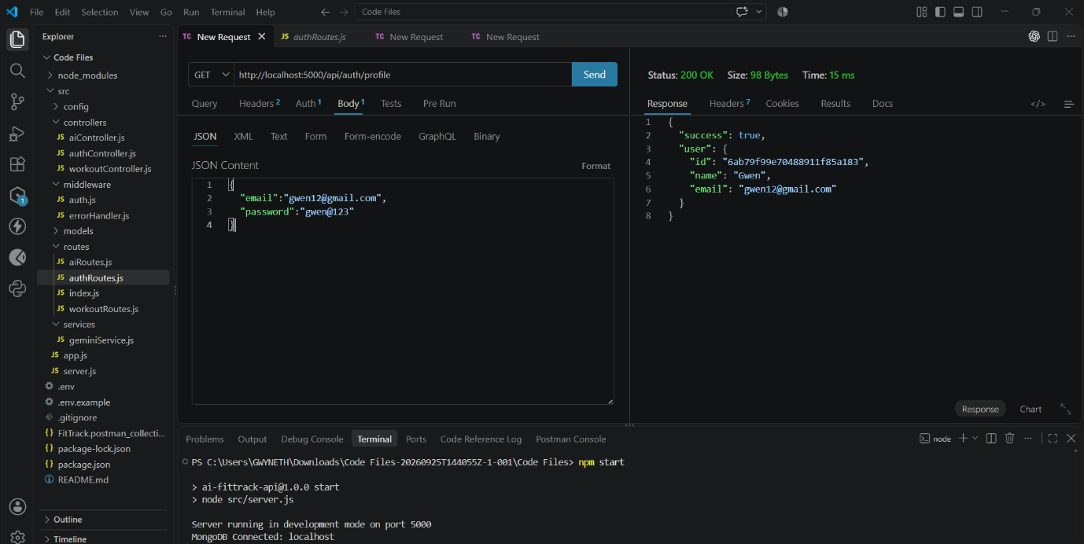
Workout API Testing
Add Workout
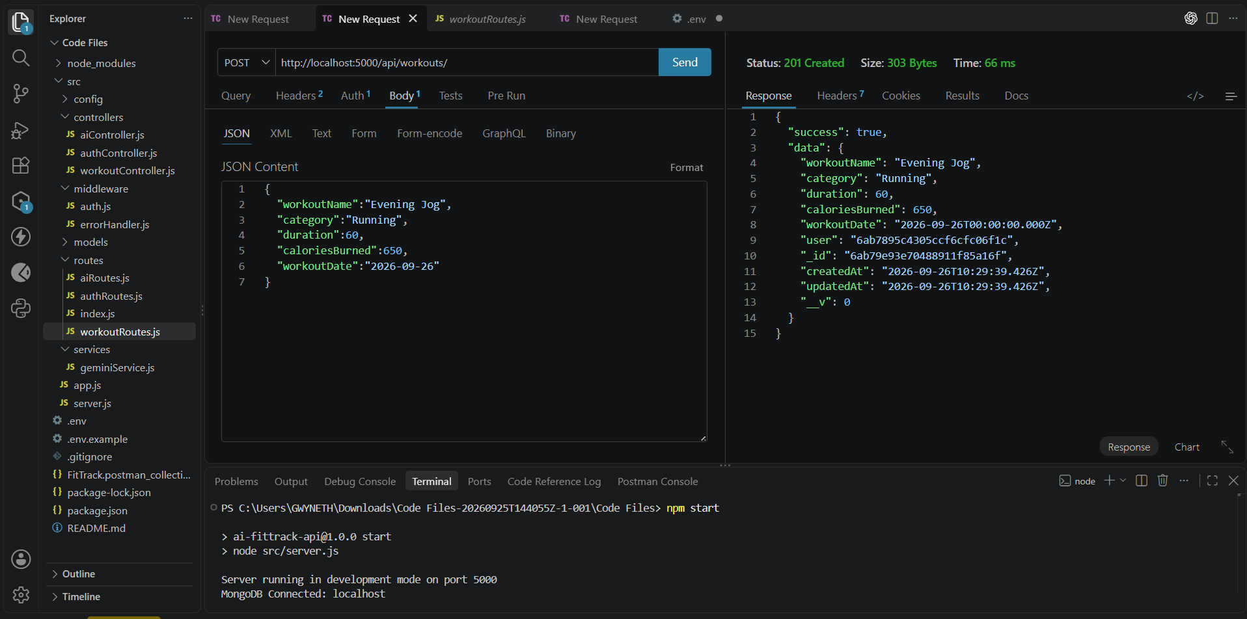
Get All Workouts
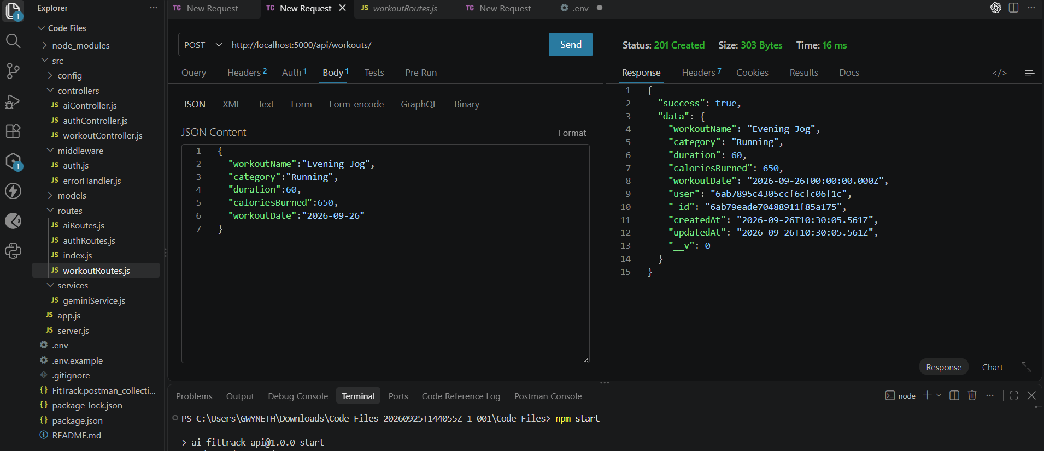
Get Workout By ID
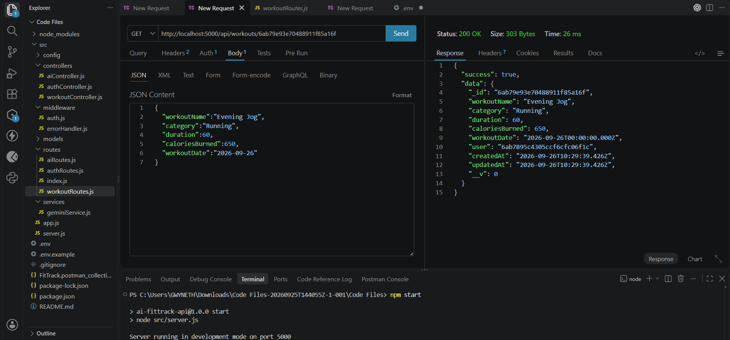
Update Workout
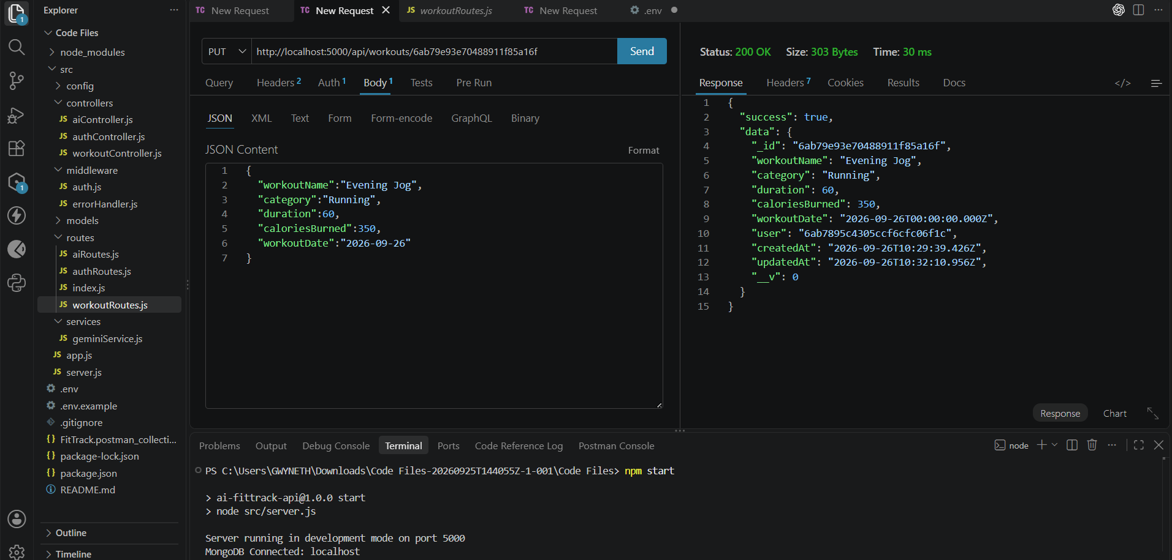
Delete Workout
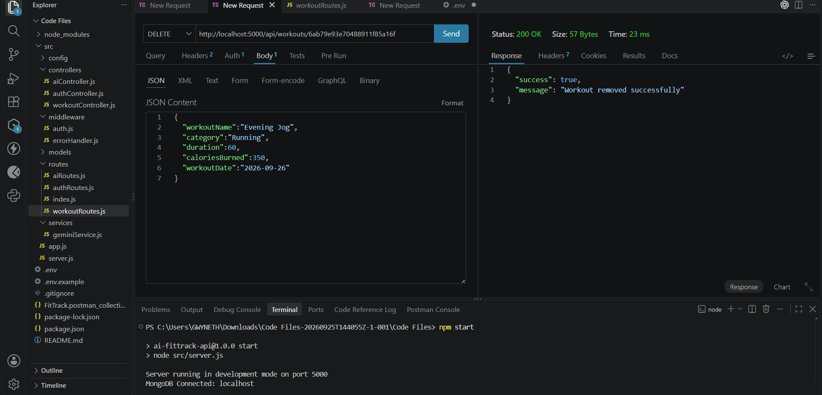
AI API Testing
Workout Recommendation
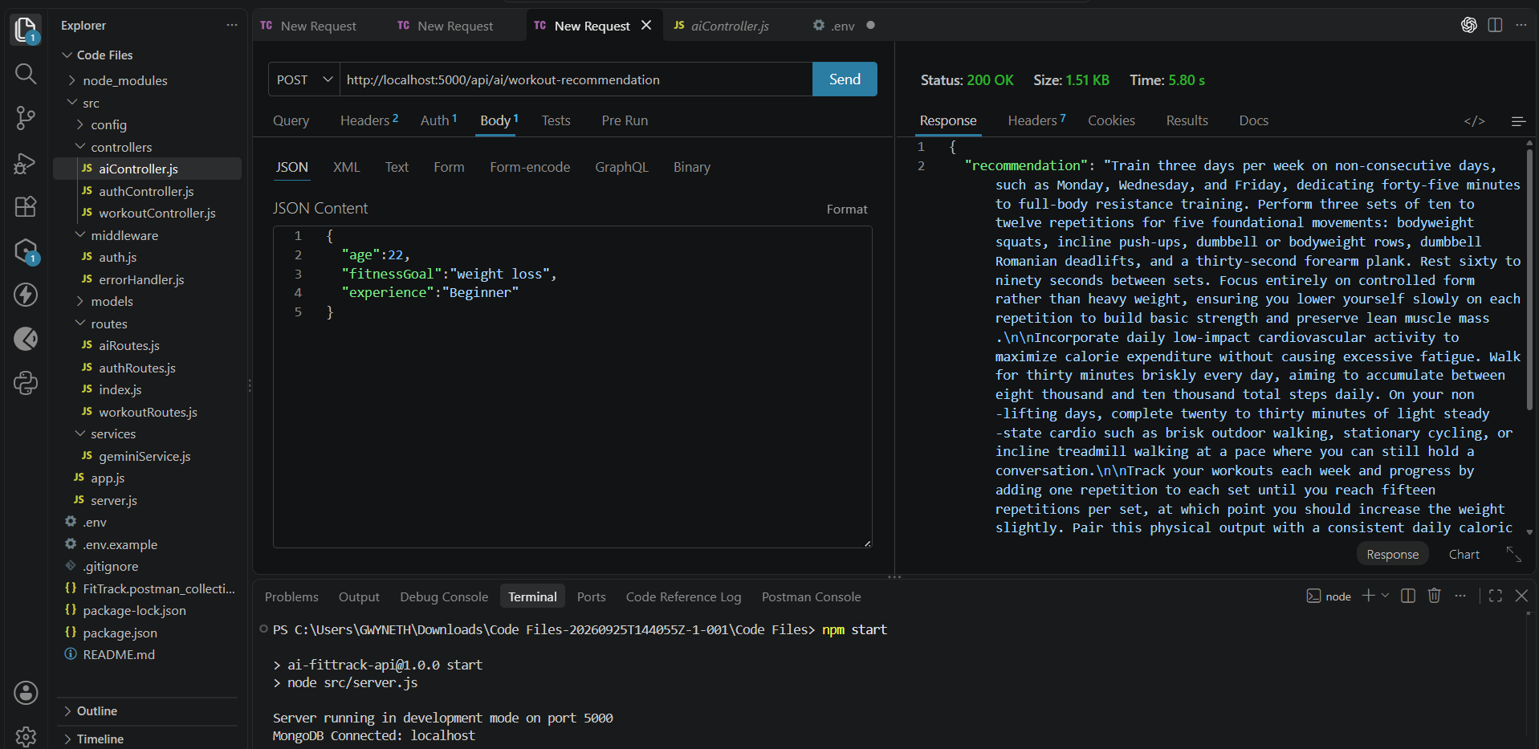
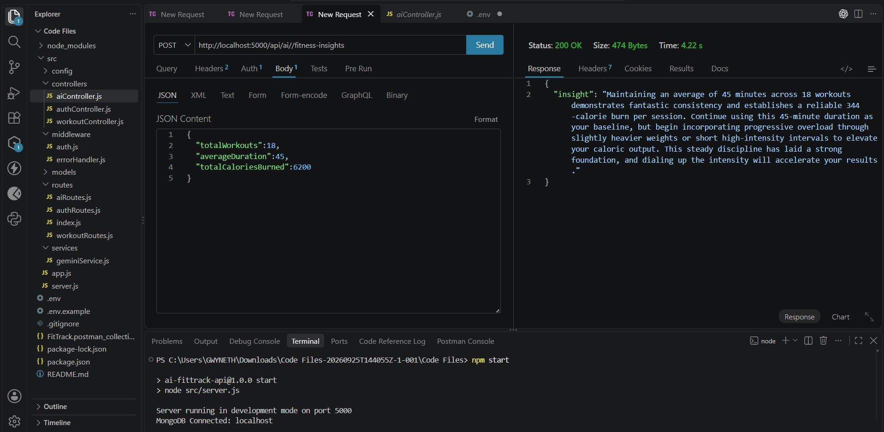
Fitness Insights

17. Project Outcome
AI Fit Track API provides a complete backend foundation for a fitness application. It combines secure authentication, workout CRUD operations, searchable workout history, MongoDB persistence, and AI-powered fitness assistance in a modular Node.js application.
The project demonstrates practical backend development concepts including REST API design, MVC architecture, middleware, authentication, database integration, third-party AI integration, environment configuration, and API testing.
14. Future Enhancements
- Nutrition and meal tracking.
- BMI and general fitness metric calculation.
- Workout reminders and scheduling.
- Wearable device integration.
- Progress charts and analytics dashboards.
- Personalized workout history and recommendations.
- Role-based administration.
- Mobile or React frontend integration.
- More detailed AI-based fitness analytics.
Conclusion
AI Fit Track API successfully demonstrates how Node.js and Express.js can be used to build a secure, modular REST backend with MongoDB and Google Gemini AI. The project provides users with a structured way to manage workout information while receiving personalized AI-assisted guidance.
The architecture is designed for future expansion, allowing additional fitness features to be integrated without changing the core organization of the application.

